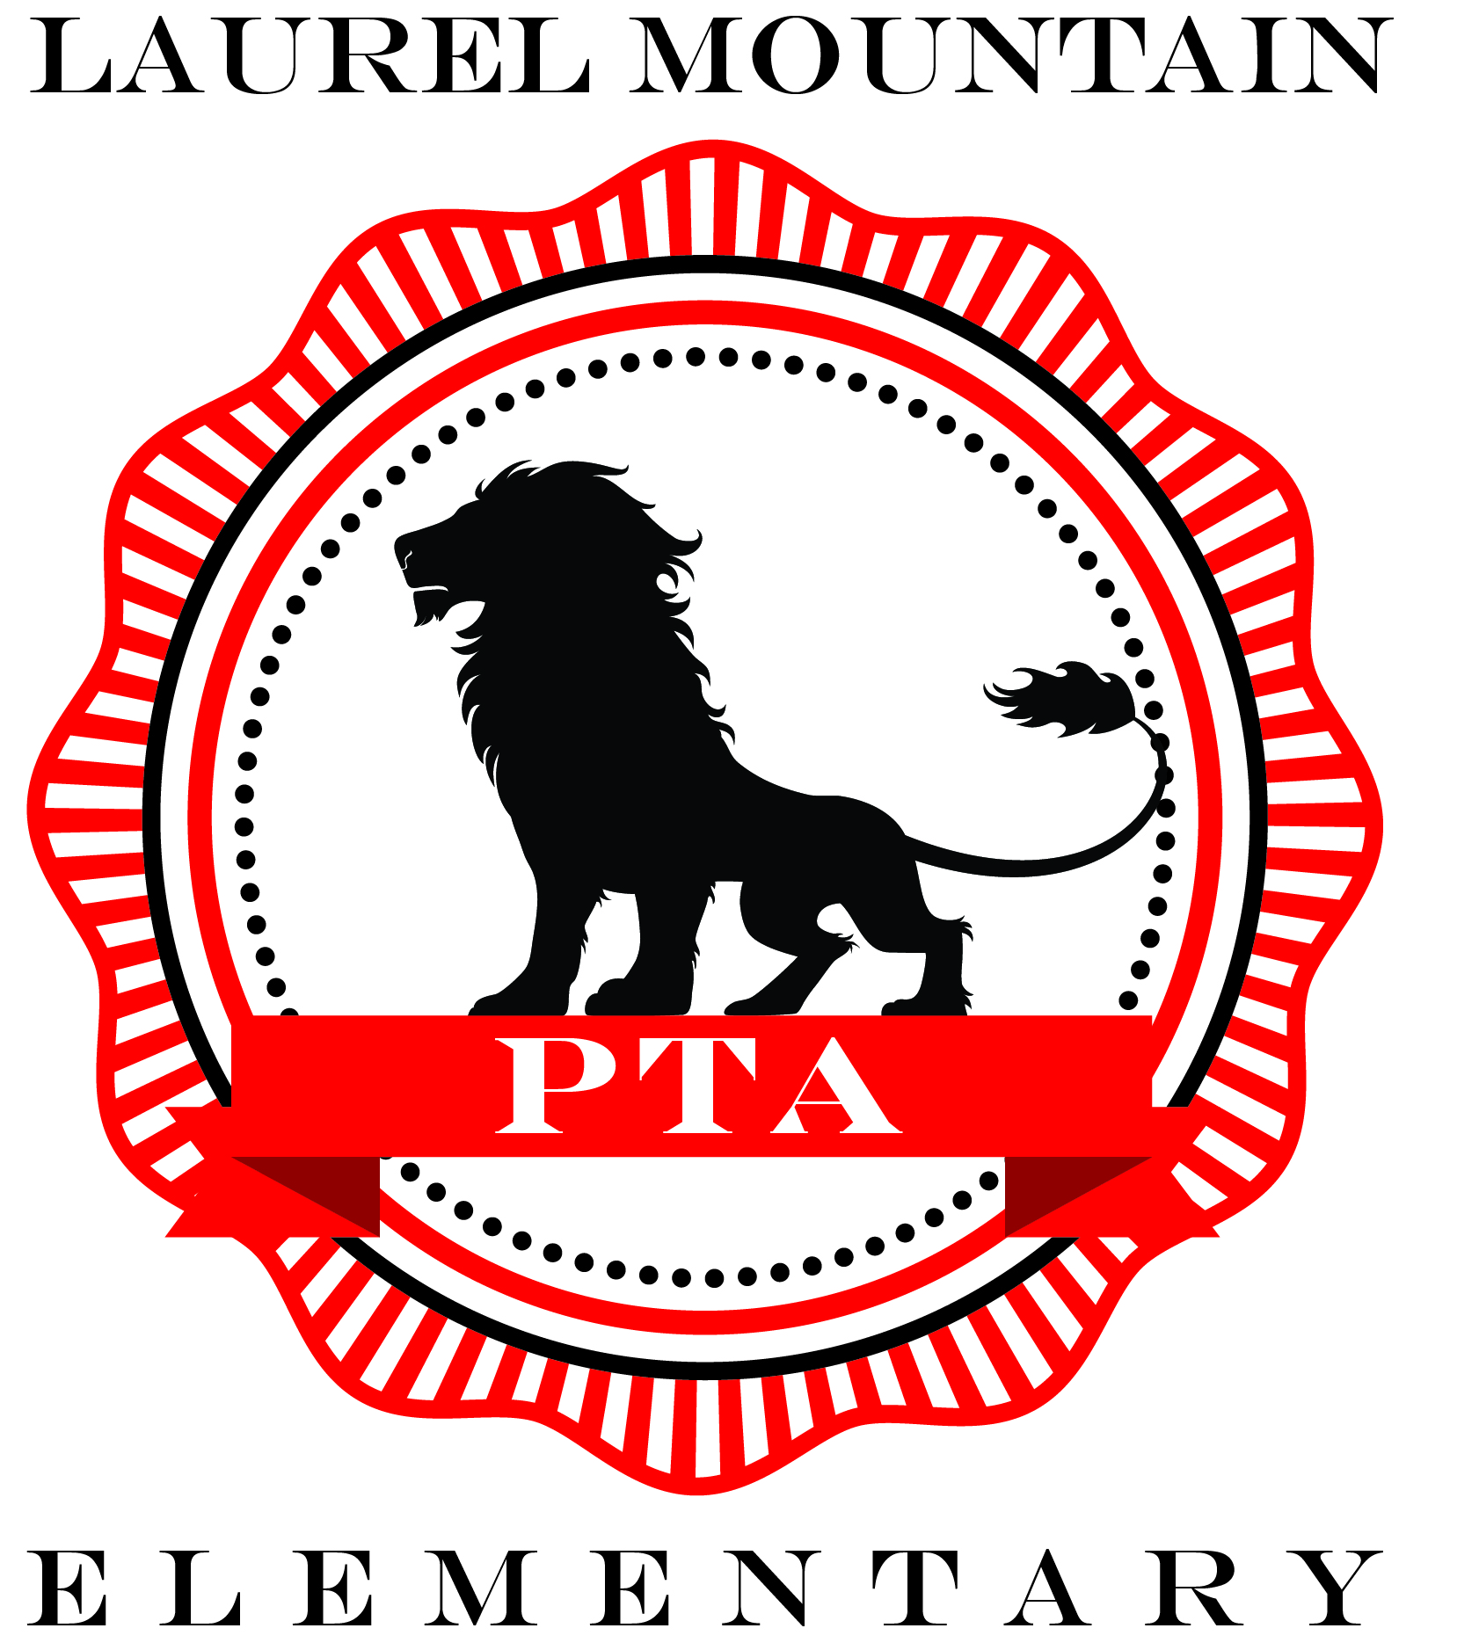

Laurel Mountain Elementary School PTA located in Northwest Austin is thankful for its PTA sponsors and the support provided by the local businesses. Our PTA hosts many things throughout a school year and without our sponsors we would not be able to invest in our school, children, and our teachers.

If you are interested in finding out more about these opportunities, please contact Vicki Walker at 512-924-5153 or [vickiwalker4@hotmail.com](mailto:vickiwalker4@hotmail.com).

|  |  |  |  |  |
| --- | --- | --- | --- | --- |
| **Level** | **$1,500** | **$1,000** | **$500** | **$250** |
| Constant logo in online directory. | • | • |  |  |
| Banner with logo at school for 2017-2018 school year | • | • |  |  |
| Table at Fall Carnival and Spring Pride Night | • | • |  |  |
| Sign at Fall Carnival and Spring Pride Night | • | • | • |  |
| Logo on PTA website and Facebook page | • | • | • | • |
| Sponsor recognition emails sent to PTA members (3x during 2017-2018 school year) | • | • | • | • |
| Ad in online directory | • | • | • | • |
| Certificate to display | • | • | • | • |

**Diamond Lion: $1,500 (maximum of 3)**

* *Constant logo in online Student Directory*.
* Logo on 3 ½’ x 5 ½’ banner to be hung at the school for 2017-2018 school year
* Option to set up table at the Fall Carnival and Spring Pride Night and to distribute swag/flyers
* Logo on sign at the Fall Carnival and Spring Pride Night
* Logo on PTA website and Facebook page for 2017-2018 school year
* Logo on the Fall Carnival and Spring Pride Night flyers for 2017-2018 school year
* Three sponsor recognition emails sent to PTA members during 2017-2018 school year

**Platinum Lion: $1,000 (maximum of 5)**

* Logo on 3’x5’ banner to be hung at the school for 2017-2018 school year
* Option to set up table at the Fall Carnival and Spring Pride Night and to distribute swag/flyers
* *Constant logo in online Student Directory.*
* Logo on sign at the Fall Carnival and Spring Pride Night
* Logo on PTA website and Facebook page for 2017-2018 school year
* Logo on the Fall Carnival and Spring Pride Night flyers for 2017-2018 school year
* Three sponsor recognition emails sent to PTA members during 2017-2018 school year

**Gold Lion: $500**

* Logo on sign at the Fall Carnival and Spring Pride Night
* Logo in online Student Directory
* Logo on PTA website and Facebook page for 2017-2018 school year
* Name recognition on the Fall Carnival and Spring Pride Night flyers for 2017-2018 school year
* Three sponsor recognition emails sent to PTA members during 2017-2018 school year

**Silver Lion: $250**

* Logo in online Student Directory
* Logo on PTA website and Facebook page for 2017-2018 school year
* Name recognition on the Fall Carnival and Spring Pride Night flyers for 2017-2018 school year
* Three sponsor recognition emails sent to PTA members during 2017-2018 school year

***\*We welcome our supporters to provide pre-approved, in-kind contributions to help fulfill your Laurel Mountain sponsorship commitment! Please note that all flyers, swag, and artwork for logos and ads must be provided by sponsors.***